SINDICATO NACIONAL DE TRABAJADORES DEL SISTEMA AGROALIMENTARIO
SINALTRAINAL
NIT. 860.517.322-7
Personería Jurídica 04185 Diario Oficial No. 36207 Del 9 de Diciembre / 82 Del 7 de Marzo / 83

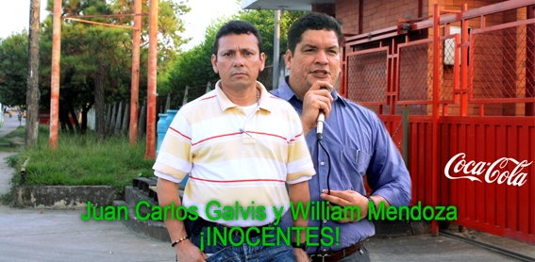
“FOR THE FREEDOM TO UNIONIZE AND DEMOCRACY”
We Are Innocent!

Juan Carlos Galvis and William Mendoza, employed by Coca Cola and national union Readers of SINALTRAINAL, are victims of constant labor rights violations, including false accusations by paramilitaries and the Colombian government’s policy of using the judicial system to falsely accuse labor rights defenders.

The 28th Office of the National Unit against Terrorism of the Attorney General’s Office ordered the opening of investigation No. 290 for aggravated conspiracy to commit a crime and presumably terrorism.

The investigation was opened on the basis of accusations made during confessions under the jurisdiction of the Justice and Peace Process by the following paramilitaries: Saúl Rincón, Wilfred Martínez Giraldo “Alias Gavilán,” and Rodrigo Alzate “Alías Julián Bolívar.”

This false accusation was prepared from the jails. The situation was quickly denounced by SINALTRAINAL, and we formally solicit the exclusion of these paramilitaries from the Justice and Peace Process. However, despite the denouncement, these investigations have not moved forward and their status remains uncertain. On the contrary, the Attorney General decided to open the case against Juan Carlos and William.

This new false accusation against members of SINALTRAINAL is part of a policy to systematically persecute members of the union movement. We continue to be victims of murders, death threats, attempts, displacement, exile, torture, attempted kidnappings, illegal wiretapping by the DAS, perverse set-ups, and false accusations, among other crimes.

On February 8, 1999, issue 295 of Cambio Magazine said that the guerrillas supported SINALTRAINAL in the labor conflicts with Coca Cola. Since then, Juan Carlos and William have been forced to confront the following incidents that gravely affect their security and the existence of SINALTRAINAL.
Denouncements by Coca Cola before Colombian Authorities: 3
Opening of judicial processes: 3
Spying by the Colombian state by the DAS: 1
Death threats: 9
Attacks: 13
Illegal Surveillance: 3
Assassination Attempts: 3
Raids: 1
Armed terrorist attacks: 1
Exile 1

We have denounced these activities before the appropriate authorities, but we are not aware of the current state of the investigations.

Recommendations:

- The U.S. government, U.S. Congress, Congressional Monitoring Group on Labor Rights on Colombia, and U.S. civil society should monitor the Colombian judicial system in order to ensure efficient investigations. The investigations should respect the right to defense, innocence until proven guilty, and due process. The law, not politics, should define the court’s decisions.
- They should urge the Colombian government to immediately cease the criminalization of innocent people that never had anything to do with these false accusations because those responsible for the crimes against humanity are in the Justice and Peace Process.
- They should also urge the Colombian state to guarantee security and the right to life of members of trade unions.

National Committee of SINALTRAINAL
Colombia, Marzo 24 de 2012

