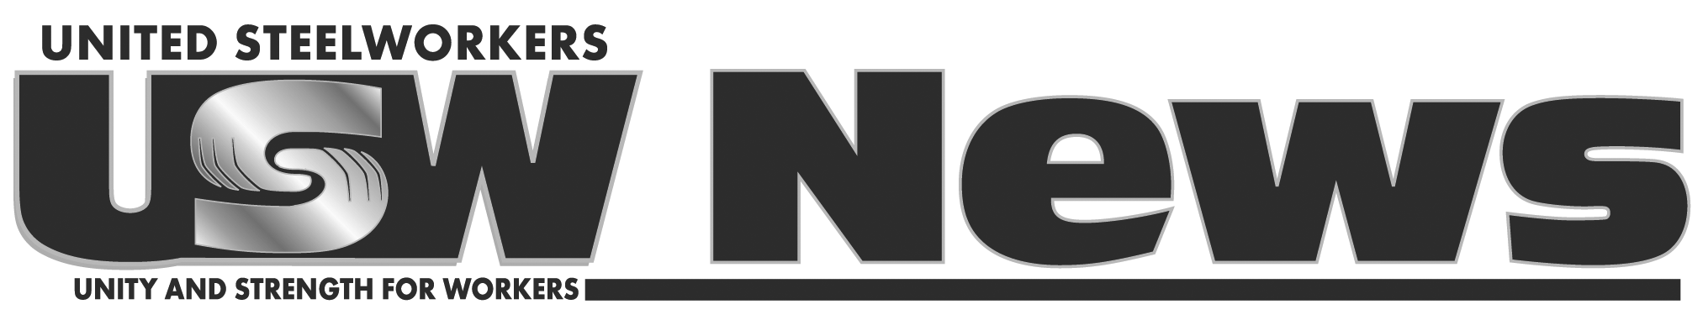

For Immediate Release: April 15, 2012
Contact: Gary Hubbard, 202-256-8125, ghubbard@usw.org;

USW Decries U.S. Pronouncement of Colombia's Compliance
With Labor Action Plan; Vows Defense of Colombian Unionists

AFL-CIO Declaration Issued to Re-examine Colombia FTA on worker rights

Pittsburgh (Apr. 15) -- The USW strongly disagrees with today’s U.S. pronouncement that Colombia has complied with the Labor Action Plan -- a move which will allow for implementation of the Free Trade Agreement (FTA) starting next month.

The USW, the AFL-CIO and the Colombia labor movement firmly believes the U.S. pronouncement is premature as unionists continue to be killed in Colombia -- at a rate of 30 slain in 2011, and six already this year. According to records made public, impunity for prosecution of such killings remains high at around 95 percent.

Leo W. Gerard, USW International President, said, “In light of such violence and impunity, Colombia continues its shameful distinction as the most dangerous country in the world to be a trade unionist." He confirmed support of a joint declaration issued today by AFL-CIO President Richard Trumka with leaders of the national Colombian labor unions CUT and the CTC that was critical of the FTA implementation.

He adds: “It remains the position of the USW that the withholding of FTA implementation until the rates of anti-union violence and impunity are dramatically reduced is the surest form of leverage the U.S. has to safeguard the lives and well-being of unionists in Colombia.

“We implore the U.S. government to refrain from giving up this leverage and to indefinitely postpone the implementation of the FTA. This is the only way to ensure Colombia's future good conduct, and to properly honor the almost 3,000 unionists killed in Colombia since 1986.”

In a statement published earlier this week on the slaying of a Florida teenager named Trayvon Martin, Gerard said, “Americans don’t countenance murder, particularly when racially or politically motivated. Americans are justice-seeking and fair-play believing. And that is why we as a country cannot certify that Colombia has fulfilled its obligations under the Labor Action Plan.” Certification under the plan was seen as a necessary step before the FTA was implemented.

He declared, “The USW is committed to working in solidarity with Colombian unions to help bring about this improvement, to defend the very lives of Colombian workers and to fight the implementation of the FTA until they are safe from threats, violence and murder."
# # #

