- Trump did not stop job offshoring, contrary to his 2020 claims and 2016 campaign pledge

  - More than 300,000 more American jobs have been lost to offshoring and trade during Trump’s presidency, as certified by the Labor Department. The Economic Policy Institute says total trade job loss is much higher — estimating 700,000 jobs lost to China alone in just Trump’s first two years.

- Michigan’s trade-related job loss has more than doubled over the last three years. During the Trump administration, Michigan hemorrhaged jobs to offshoring with a 211% increase in trade-related job loss. (From 2017-2019 TAA-certified job loss was 15,675 compared to 7,428 for 2014-2016.) It’s getting worse: Michigan suffered a 308% increase in trade-related job loss in 2019 over 2018.

- Nationwide, 311,427 American jobs have been government-certified as lost to trade during Trump’s presidency with 192,382 explicitly listed as offshored. (This 9/25/20 data represent an undercount, but are the best data available. The figure only incudes workers DoL approved for Trade Adjustment Assistance, a voluntary program that workers must know of, apply for and prove trade caused job loss. And the data doesn’t include all 2019 losses or most 2020 because of processing lags.)

- Trump promised to stop Carrier workers’ jobs from being offshored, but almost 600 of the union workers at Carrier’s Indianapolis plant lost their jobs and all 700 of Carrier’s Huntington Indiana jobs were offshored to Mexico. During the Trump presidency, Carrier parent firm United Technologies offshored at least 1,572 jobs according to government data.

- During the Trump presidency, GM closed U.S. plants and moved popular vehicle lines to Mexico; Ford announced its new Mustang electric SUV will be made in Mexico; Boeing offshored 5,800 jobs, General Electric offshored 2,046, and United Technologies offshored 1,572 jobs. The Machinists and Steelworkers have lost dozens of facilities to offshoring during the Trump presidency.

- Trump did not quickly end the trade deficit - it is 18% higher than in Obama’s last year
  - U.S. Census Bureau data show that the U.S. trade deficit in the first seven months of 2020 under President Trump is 18% higher than it was during the same period during President Obama’s last year in office in 2016. This is especially troubling given trade volumes crashed 15% due to the COVID-19 pandemic. (Inflation adjusted: $356 billion trade deficit 1-7/2020 compared to $302 billion during the same period 2016.)

- In July 2020, the U.S. had the largest monthly goods trade deficit ever recorded and the largest overall monthly trade deficit since July 2009 during the global financial crisis and recession.

- Trump didn’t turn around manufacturing job loss, offshored jobs not “all coming back”

- More workers filed for government aid for trade job loss in 2019 than Trump’s first year, per a report from his Labor Department. (1231 TAA filings in 2019 and 1091 in 2017.) TAA filing stayed high during Trump’s presidency: 88,000 in 2019; 77,499 in 2018; and 95,505 in 2017.)

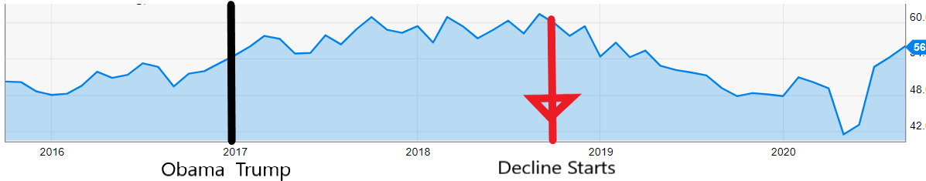
- During the Trump administration, U.S. manufacturing started a decline in late 2018, well before the COVID-19 crisis. Manufacturing growth began in Obama’s last two years and continued into the first two years of Trump’s presidency before a year of decline in 2019.
Data from U.S. Institute for Supply Management Purchasing Managers Index

- The data show there is no Trump “blue-collar job boom.” Annual average manufacturing job gains during the entire 2010-2019 recovery was 166,000, which accounts for the 500,000 gain in U.S. manufacturing jobs from 2016 to 2019. There was no Trump jump relative to prior years and total gains account for a small fraction of the 4.5 million manufacturing jobs lost since 2000.

- Trump’s mishandling of the COVID-19 crisis has wiped out 750,000 American manufacturing jobs. See here for live version of the EPI graphic below that shows jobs per month.
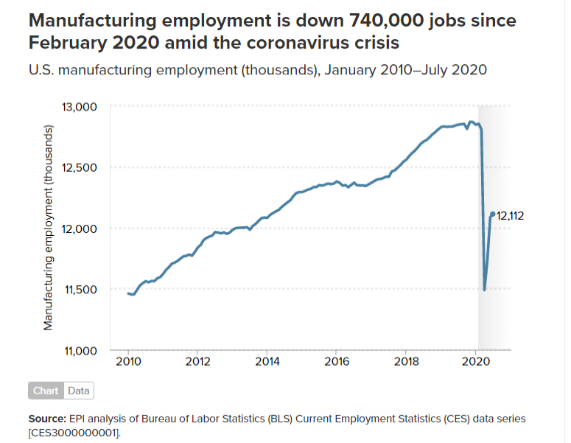

- Trump created new incentives to offshore jobs

  - Trumps tax policy rewrite created new incentives to offshore jobs with a 21% corporate tax rate for income earned domestically but 10.5% for profits earned offshore.

- The “Phase-One” Trump-China trade deal made it safer and easier for big corporations to offshore with new investor and intellectual property protections for firms that move production to China. But there’s nothing in the deal to end forced labor in China, or require basic worker rights or environmental protections to stop the race to the bottom. Nor are there disciplines against China’s massive subsidies that make it impossible for U.S. firms to compete.

